Final Project Proposal

“BudgetBuddy” Personal Finance Web App

1. Overview
BudgetBuddy is a simple personal finance and money web application designed to help people track expenses, understand their spending patterns, and also convert currencies using real-time exchange rates. Many individuals, especially students like myself and young professionals, struggle to maintain a clear picture of their daily spending.
The problem:
People often overspend because they lack a centralized, visual way to see where their money goes or went.
My motivation:
Managing personal expenses is a personal need for me and a universal need. Secondly, creating a lightweight budgeting tool will reinforce my understanding of APIs, data visualization, and frontend web development. This project also solves a real problem I personally experience by keeping track of my spending.

2. Target Audience
BudgetBuddy is designed for:
- Students trying to manage their limited budgets
- Young professionals tracking spending across categories
- Travelers who need currency conversion
- Anyone who wants a simple, no-login budgeting tool

3. Major Functions

1. Add New Expense
Users can enter an expense with the amount, category, description, and date. Stored in localStorage.

2. Expense History List
Will display all expenses in a clean list format: newest first.

3. Category Filters
Users can filter expenses by category (Food, Transport, Shopping, Bills, Others).

4. Monthly Summary Chart
A visual pie chart showing how spending is distributed across categories.

5. Currency Conversion Tool
Integrates live data from “ExchangeRate API” to convert an amount from one currency to another.

6. Random Financial Tip Generator
Uses the “Advice Slip API” to display simple finance tips.

7. Set Monthly Budget
Users can set a monthly budget limit; the app tracks the remaining balance.

8. Budget Alert System
Users will receive a notification when expenses exceed the monthly budget.

9. Save Data in Local Storage
All user data (expenses, budgets, preferences) is stored locally, so no login is required.

10. Dark Mode / Light Mode Toggle
User can switch between theme; state is saved.

4. Wireframes (Mobile + Desktop)

Desktop View

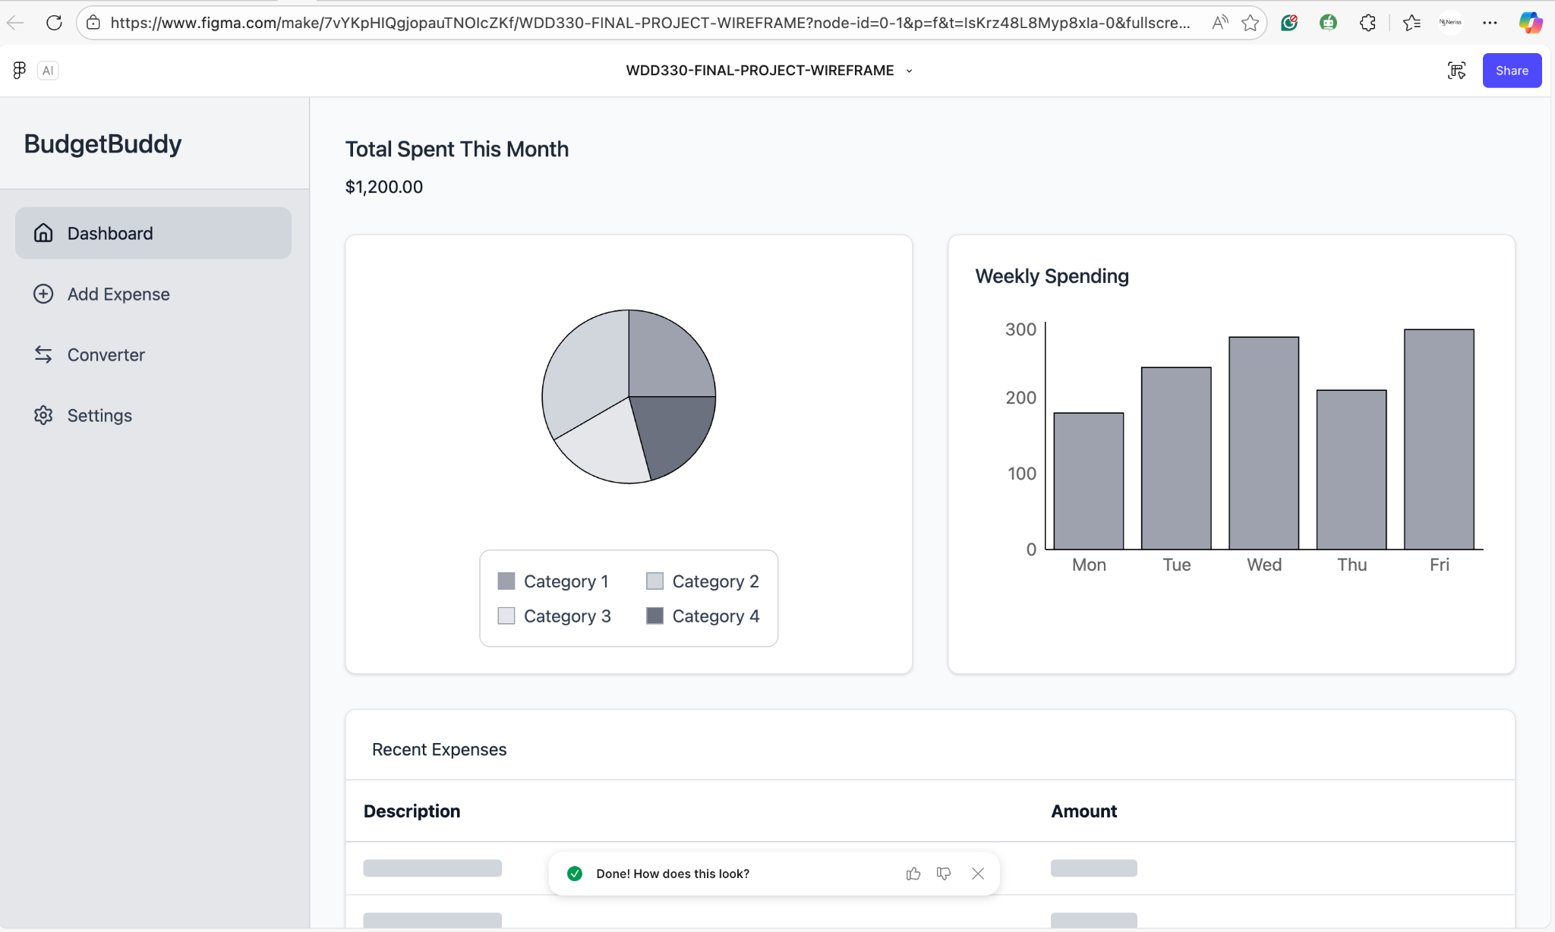

Mobile View
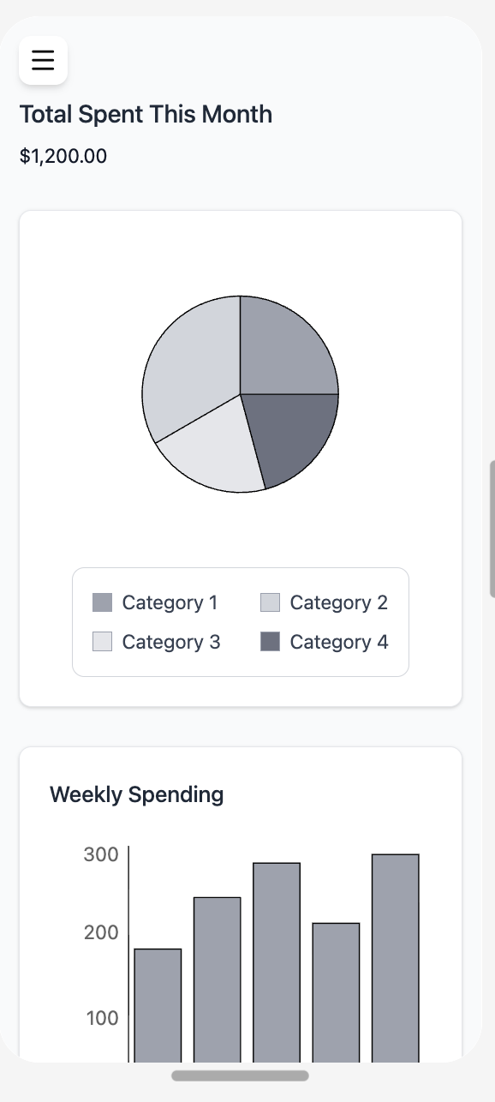

https://sweat-stand-96794508.figma.site/

5. External Data (APIs)

API 1: ExchangeRate API
Purpose:
- Will get real-time currency exchange rates
- Convert user-entered amounts
API Endpoint Example:
https://api.exchangerate-api.com/v4/latest/USD

API 2: Advice Slip API
Purpose:
- Display random financial/life advice
- Motivational quotes
Advice Slip Endpoint:
https://api.adviceslip.com/advice

6. Module List

1. App Shell Module
Handles routing between pages (Home, Add, Convert, Settings).

2. Expense Manager Module
Creates, stores, retrieves, filters, and deletes expenses.

3. Budget Manager Module
Manages monthly budget and warnings.

4. Currency Converter Module
Fetches live exchange rates and handles conversion.

5. Advice/Quotes Module
Fetches and displays random tips.

6. Chart Module
Generates pie charts and bar charts using a JS library (Chart.js).

7. Theme Module
Handles dark mode and light mode settings.

8. Local Storage Module
Ensures all app data is saved and retrieved.

9. UI Rendering Module
Handles layout updates, DOM interactions, and styling.

10. Data Validation Module
Prevents invalid entries.

7. Graphic Identity (Branding)

Color Palette
- Primary Blue: #2E86C1
- Deep Navy: #1A5276
- Light Mint: #ABEBC6
- Soft Gray: #F2F4F4
- Warning Red: #E74C3C

Typography
- Headings: Poppins (bold)
- Body Text: Inter or Roboto (regular)

Icon Design
BudgetBuddy Icon:
A simple minimalist piggy bank icon with a dollar symbol.
Color: White on deep navy background.

8. Timeline

Week 5 – Structure and API Setup
- Create HTML structure and navigation
- Build all pages: Home, Add, Dashboard, Converter, Settings
- Test API calls for ExchangeRate + Advice API
- Set up localStorage structure
Deliverables:
Working skeleton app + successful API calls.

Week 6 – Functionality
- Add expense creation and filtering
- Build currency converter
- Install and configure Chart.js
- Add charts (pie + bar) to the dashboard.
- Add monthly budget and warnings.
- Add theme toggle
- Begin styling with CSS
Deliverables:
Full functionality with basic styling.

Week 7 – Finalization & Testing
- Complete responsive design (mobile + desktop)
- Polish UI and animations
- Bug fixes and edge cases
- Final testing
- Add documentation & cleanup
- Prepare final presentation
Deliverables:
Fully polished, final web application.

9. Project Planning (Trello Board Link)
https://trello.com/invite/b/68ffe71895d5114caa55afcc/ATTI27e4caa4574db75fc385e8216ebde9de679C3496/wdd330-final-project
If you want, I can generate a fully populated Trello board template with 40–60 tasks.

10. Challenges

Anticipated challenges include:
- Handling API errors (e.g., rate limits, missing data)
- Ensuring charts update dynamically when expenses change
- Making the UI fully responsive on both mobile and desktop
- Managing localStorage cleanly without duplicates
- Keeping the design visually clean while including many features

